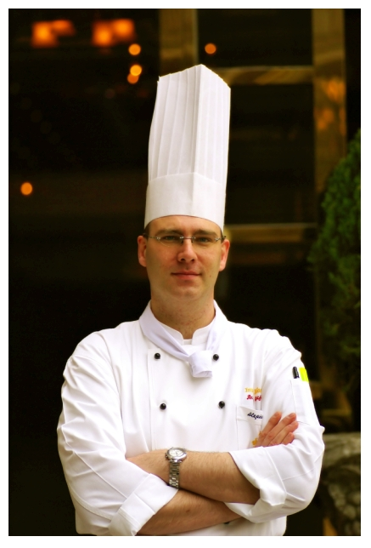
PERSONAL DETAIL

Name: Will, Stephan

Date of birth: 28.07.1972

Address: Flat 404,Studios EO31
253-1 Nohyung – Dong
Gangnam- Gu, Seoul
Korea

Telephone: 0082-(0) 2 3442 5241 Private

E-mail: me@stephanwill.com

willstephan@yahoo.co.uk

Website: www.stephanwill.com

Nationality: German

Material status: Married, 1 child

Membership: Association of Pastry Chefs of Great Britain since 1995
(Committee Member 1998-2004)
Co Editor for APC Magazine “Glaze” 2001 - 2004
The Cookery & Food Association Great Britain 2000-2004
Craft Guild of Chefs 2000-2004

Professional: EWMCS British Team 1996;Limerick, Ireland
EWMCS British Team 1995;shortlisted
East German Culinary Team; junior Masterships (1991)

Mission Statement:

“I am an Pastry Chef with extensive knowledge in managing and training of employees whose first language is not English. I have learned my profession by working over 10 years in some world-class establishments in London .I am keen competitor who always seeks new challenges for him self and likes to create valuable and unique offerings for the customers.
I am looking for an environment that enables me to grow both professional and personal by using my skills and knowledge as well as educating and training future pastry chefs.

KEY ACHIEVEMENTS

- Imperial Palace Hotel, Gangnam-Gu, Seoul/ KOREA

- www.imperialpalace.co.kr

- Pastry Chef (March 2007 – Present)

Supervising and Training of 16-20 local staff as well as introducing new concepts in all areas of Pastry and Bakery with 5 food outlets, deli counter and extensive banqueting for up to 1200. Setting up and reorganized of all systems for departmental ordering, recipe files, mise en place lists etc

  - Tokyo American Club, Minato-ku, Tokyo / JAPAN

  - www.tac-club.org

  - Executive Pastry Chef (June 2004 – August 2006)

Responsible and accountable for supervising and coordinating all activities in the Pastry & Bakery kitchen related to production for the 5 Restaurants as well as a Deli counter and extensive banqueting. Additionally responsible for assurance of consistency in product quality and cost standards while adhering to all relevant Japanese laws and regulations. Also overseeing various areas related to Human Resources including staff training, member relations as well as other duties assigned.

  - Great Eastern Hotel, London /Liverpool Street Station / UK

  - www.great-eastern-hotel.co.uk

  - Assistant Pastry Chef (October 1999- December 2003)

Part of the opening Team after extensive renovation and designing by Terence Conran, including 6 individual restaurants as well as 13 private Dining and Banqueting Rooms, producing and supervising all Pastry’s from Asian to European dishes in all outlets as well as room service and setup of internet orders for celebration cakes, set up of all systems in Pastry and training of Staff.

Silver Award: Petit fours, 2002 Hotelympia Salon Culinaire International London

Entry; Japanese Petit fours, 2000 Hotelympia Salon Culinaire International London

  - The Savoy Hotel, Strand, London

  - Banqueting Pastry Chef, Promoted from: Sous Chef (February 1998-August 1999)

Remained within budget for food costs during all banqueting season. Reorganized systems for departmental ordering, recipe files, mise en place lists etc. Supervising of production and serving of large Banqueting. Training of junior members of staff.
Organized entry for 'Afternoon Teas of the Year' competition: gained Merit Award in Final at APC London (1998)
Coached members of staff for 'Dessert of the Year' competition (1998)

  - Hyatt Carlton Tower, on Cadogan place, London

  - Acting Pastry Chef Grissini, Restaurant, Promoted from: Demi-Chef de Partie

  - Promoted from: First Commis (October 1996-January 1998)

As acting pastry chef, responsible for 80-seater 'Grissini Restaurant', producing international and Italian plated desserts and petit fours, modeled on Hong Kong Grissini Restaurant
Supervised orders for VIPs including Madonna, Michael Jackson and Roger Moore

Finalist and Merit Award winner: 'Dessert of the Year' competition (APC, London) (1997) Excellence Award winner (January 1997) Excellence Award: Employee of the Month
Bronze Award winner: 'Works in Cooked Sugar' (Senior) (Heart of England Salon Culinaire, 1997) Silver Award winner: EWMCS International Gold Platter (Limerick, Ireland, 1996)

  - Harrods ltd., Brompton Road, Knightsbridge, London
  - Demi Chef de Partie Promoted from: First Commis
  - Promoted from: Second Commis (November 1994-September 1996)

Producing 20 types of truffles, 10 different desserts, 20 gateaux, 20 types of Danish pastry and croissants, pulling sugar and chocolate centerpieces, creating gingerbread houses etc, working in restaurant, entremets and viennoisserie sections.
Assisted chef de Décor during busy periods, in creating centerpieces for all occasions and for central displays within Food Halls. as well as part of the team providing banqueting and parties for VIPs including Princess Diana and Pamela Andersen Worked on launch parties for films (e.g. Assassin: Sylvester Stallone; Mission Impossible: Tom Cruise/Nicole Kidman) etc.

Gold Award: Works in Cooked Sugar (Hotel Olympia, London, 1996)
Winner: Best Junior Pastry (William Page Challenge Trophy, Hotel Olympia, London, 1996)
Silver Award: Works in Cooked Sugar (Senior) (Heart of England Salon Culinaire, 1995)

PROFESSIONAL QUALIFICATIONS

Thames Valley University (Slough campus) (1995 - 1997)

Advanced Diploma Culinary Arts (Credits); under Professor John Hubert

NVQ Level 3: Catering and Hospitality/Food Preparation and Cooking:
Patisserie and Confectionery

Basic Certificate: Hygiene of Food Retailing and Catering

Wernigerode Catering College, Germany (1989 - 1991)
Facharbeiter: Fully Qualified Chef
Final Exams Subjects studied: Theory of Cuisine (1); Economics (1); Technology (1); Saucier/Rotisseur (1),' Entremetier (1); Boncherie (1); Gardemanger (1); Pastisser (1); Poissoner (2)

ADDITIONAL INFORMATION

Worked during holiday for ‘Raffles’ (Singapore), helped preparing title cover for Christmas issue of Asian ‘Wine & Dine’ Magazine (1997)
Part Time Teacher at college/ specializing in cooked sugar; chocolate work; petit fours; pastillage (1996)
Assisted in demonstration of cooked sugar for the Irish Panel of Chefs (Dublin) (January 1996)
2-day demonstration of cooked sugar at former college in Germany, to thank former teachers, gaining coverage in local newspapers (November 1995)
Sugar Demonstration at Southwark College (April 1997)
Radio interview for the Savoy Hotel on German specialitys (1998)
Computer literate / WINDOWS / OFFICE
Computerised ordering over FIDELIO system
Dinner for Welsh college under Savoy theme for 120 covers/ april 2000
Knowledge of ice carving
Various cookery demonstrations and promotions
Full driving licence
First aider

